**VI EDITOR ASSIGNMENT:**

1. Invoke the vi editor with a filename (which is to be created)

**vi filename**

1. Type a few lines(at least 10) in the editor. Let one or more lines contain the words given below.

delhi Mumbai chennai Mumbai

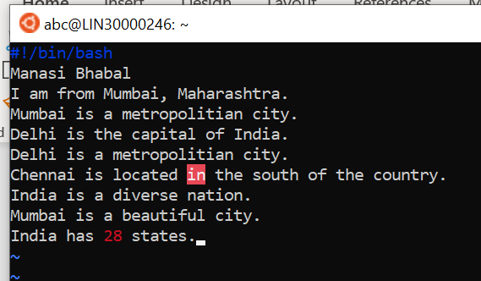

1. Save the file without exiting the editor

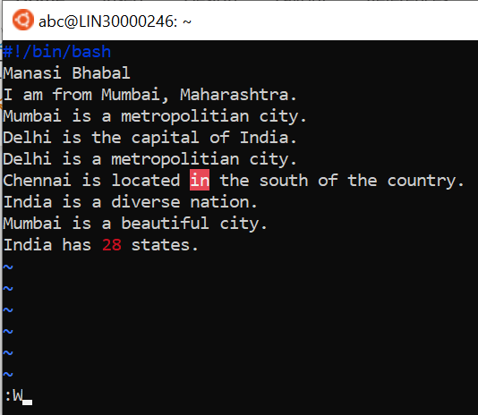

1. Navigate quickly to the beginning & end of the file

Use ggto navigate to the beginning

Use G to navigate to the end

1. Delete first two lines & copy it after the last line.

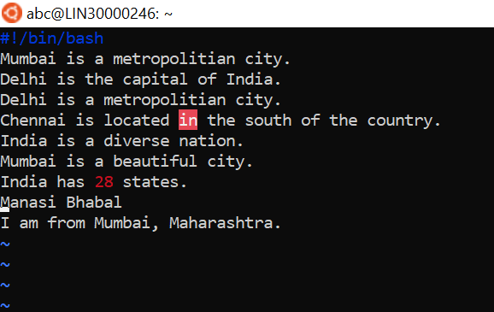

1. Now Copy the last two lines & paste them before the first line.

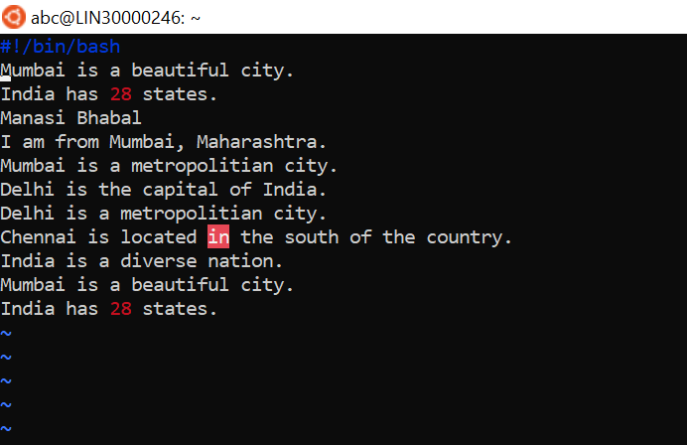

1. Combine last two lines of the file in a single line.

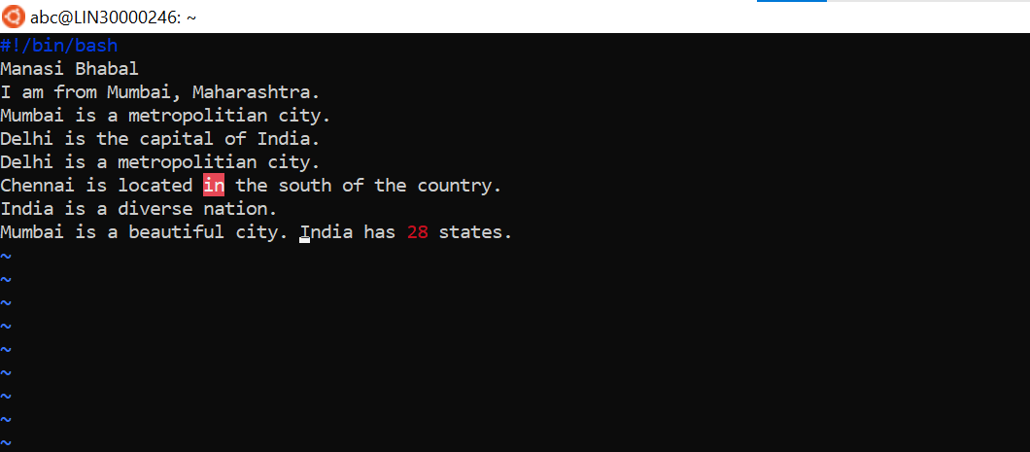

1. How will you insert a line before the first line? (Hint : Find such an option in the tutorial document)

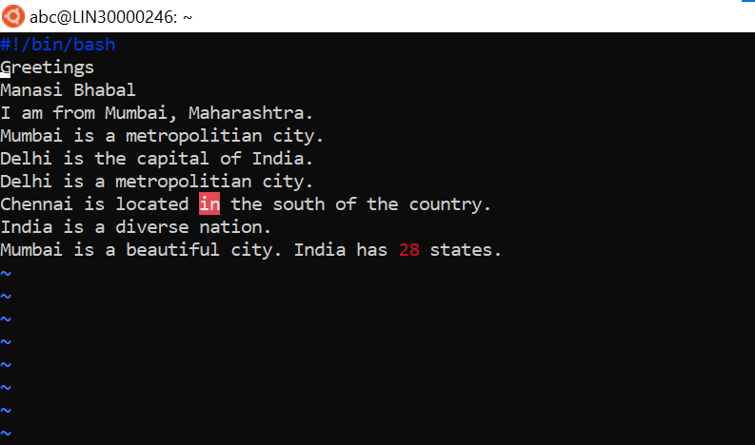

1. How will you paste a yanked buffer before the current line?

p

10. Search the document for a string “delhi”

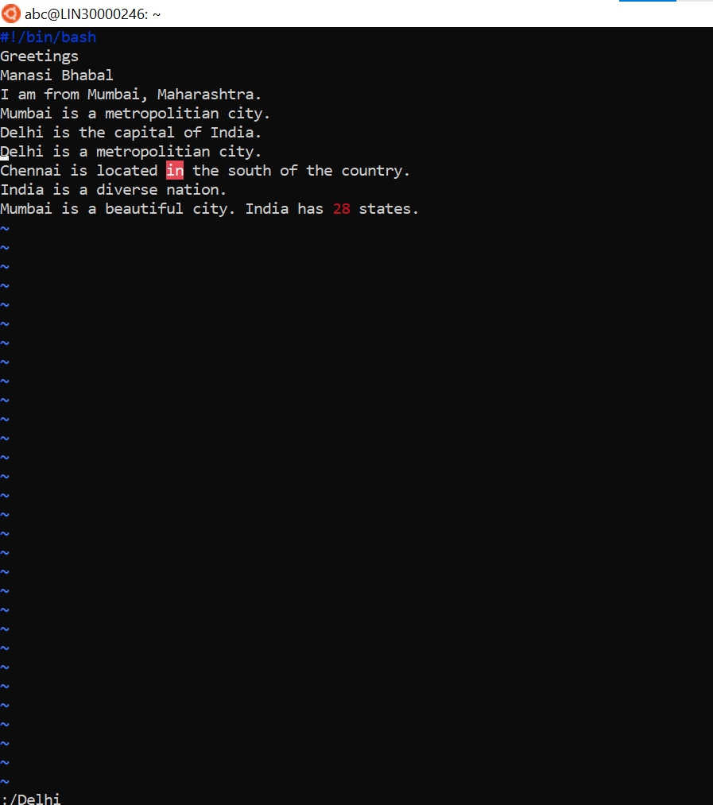

11. Replace a single occurrence of “delhi” with “Mumbai”

12. Replace all occurrences of “delhi” on a particular line with “Mumbai” using one command

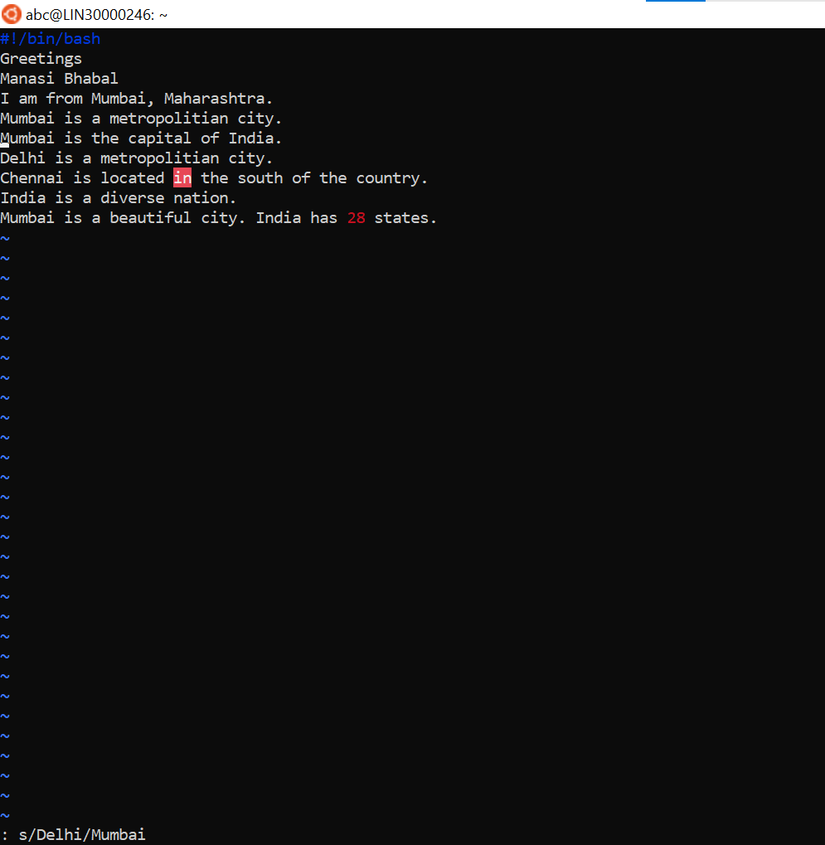

13. Replace “delhi” with “mumbai” for the entire document using one command.

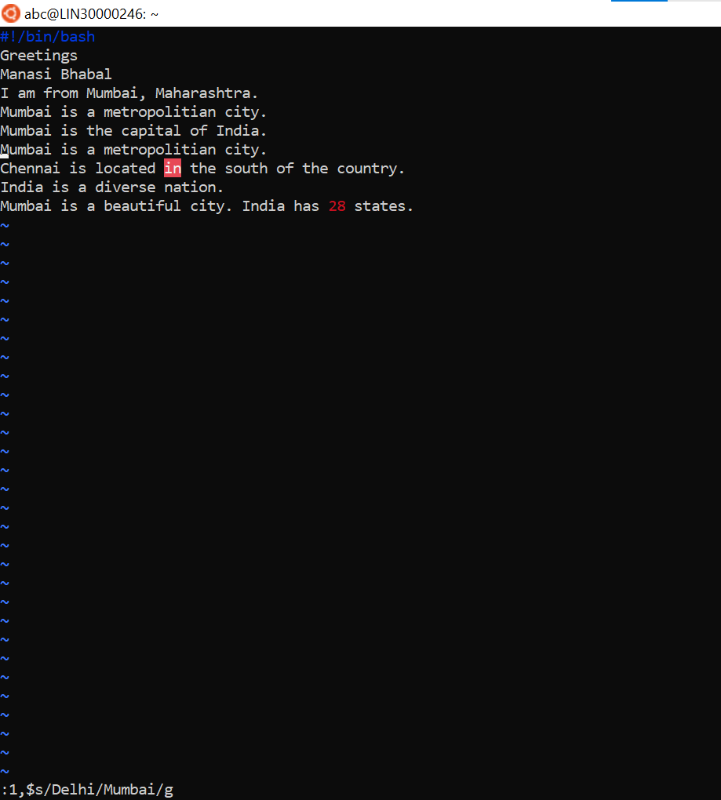

14. Replace all occurrences of “delhi” with “mumbai” for part of a document (e.g. line number 13 to 37).

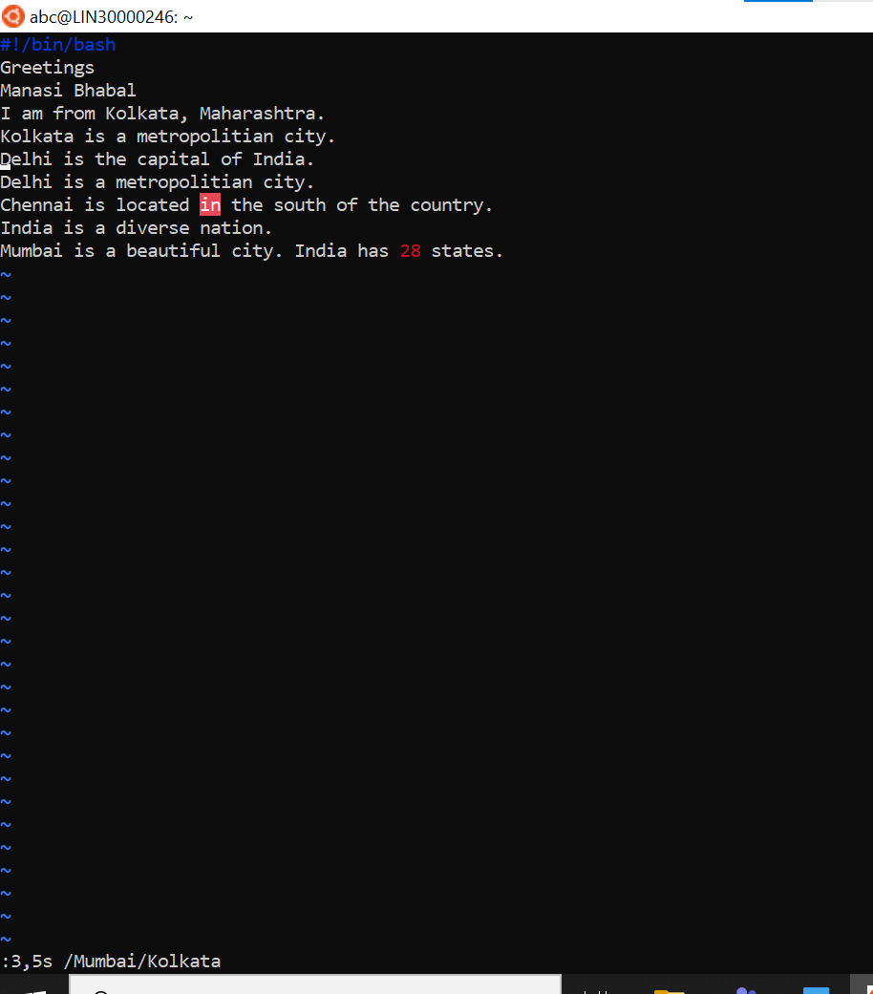

15. Undo the above command

u

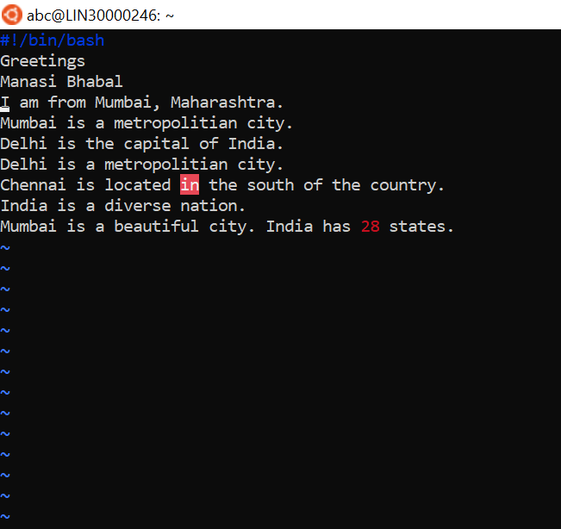

16. Replace only the first occurrence of “delhi” with “mumbai” in each line, for part of a document (e.g. line number 13 to 37).

3,6s/delhi/mumbai/gc

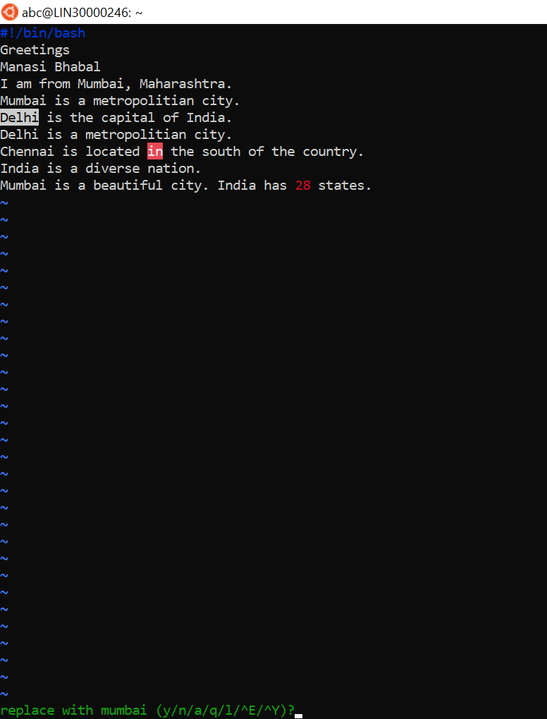

17. Undo the above comment. Redo it. Undo it again.

Use u to undo it

Then use upper arrow key two times to redo it

Then use u to undo it

18. Replace all occurrences of “delhi” with “mumbai” for complete file interactively.

3,6s/delhi/mumbai/gc (same as 16 question)



19. Search for a word backwards. Loop through all matches.

Use ?string name

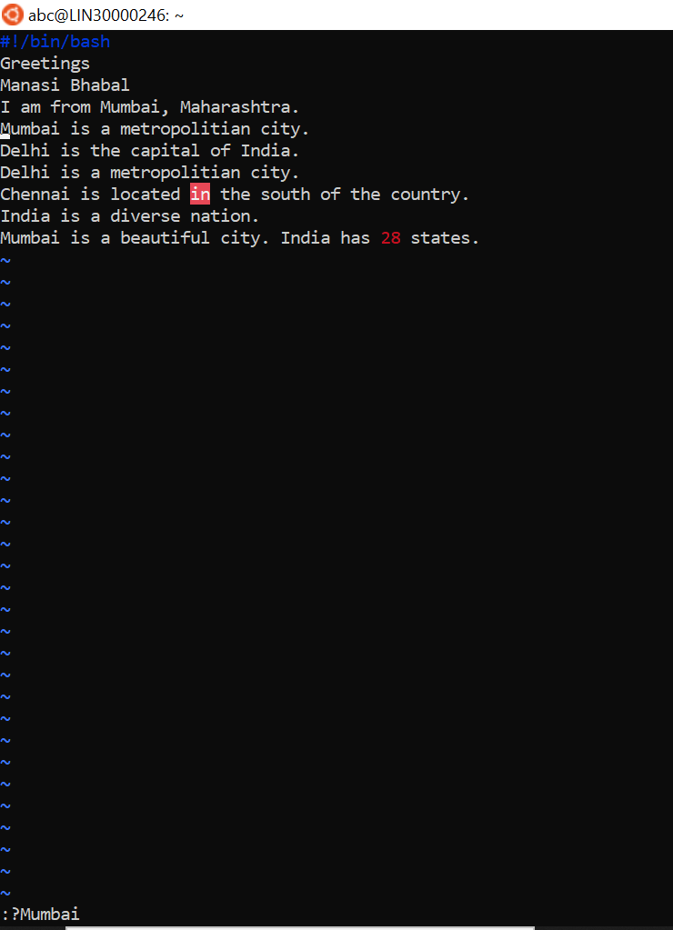

20. Search for a word forwards. Loop through all matches

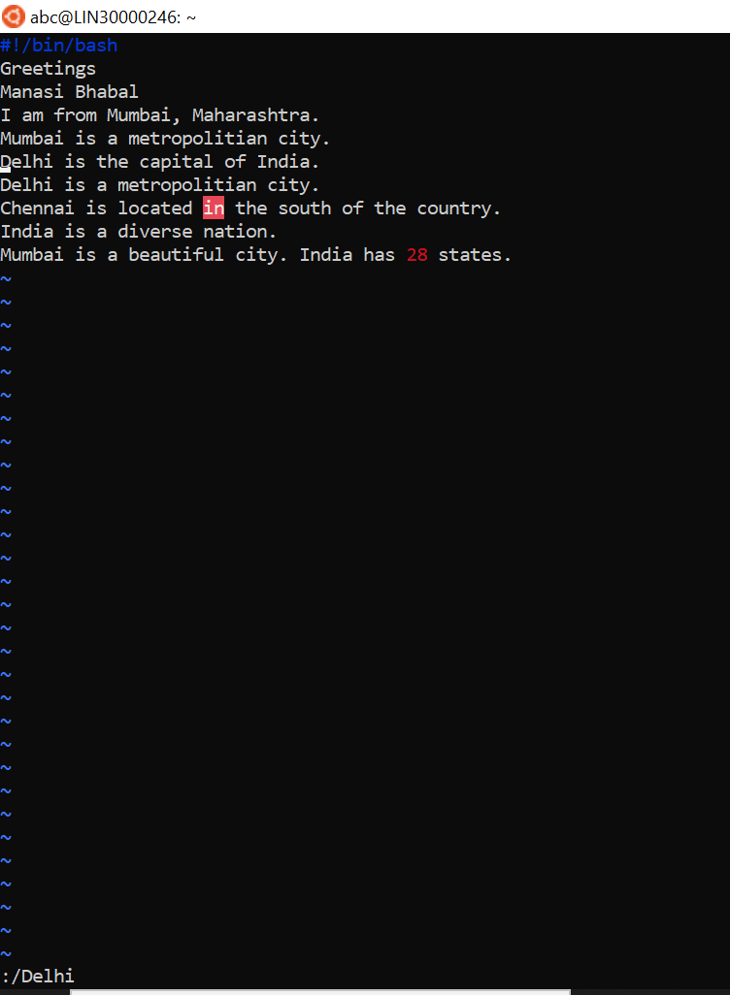

21. Join two lines together.

Use J

22. Enable line numbering and then disable it

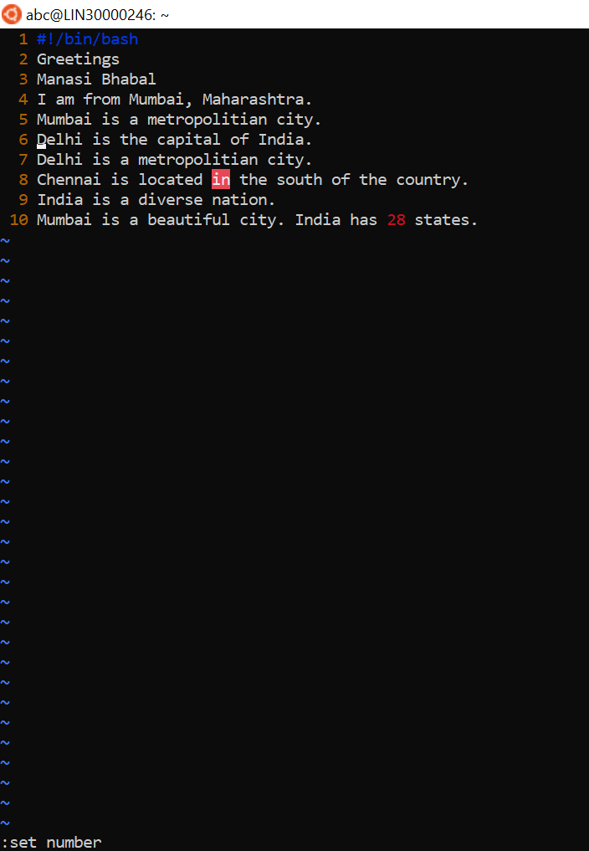

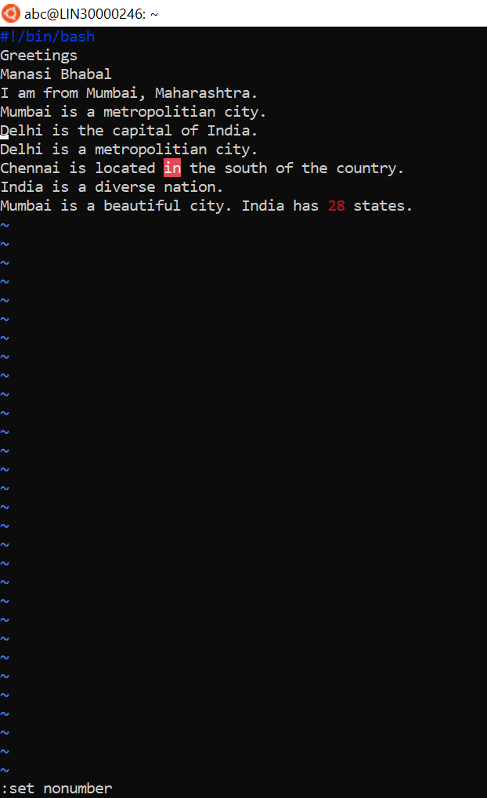

23. Make the search case insensitive

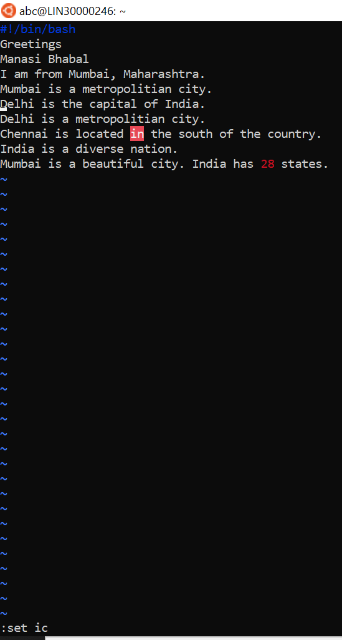

24. Delete 4 lines (and then paste them somewhere else)

4yy to copy 4dd to delete p to paste

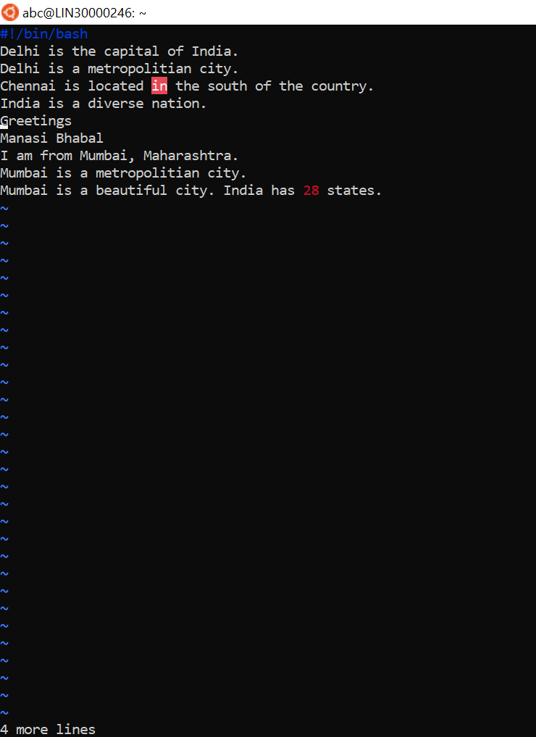

25. What is the command to delete part of the line starting from the current cursor position?

d$

26. What is the command to delete the current word?

dw